IAPA Position Statement on RAP
The Irish Asphalt Pavement Producers Association (IAPA) is a trade association representing the majority of Asphalt Producers in Ireland. Our association was founded in 2001 to promote the asphalt industry, provide representation on behalf of its members, and serve as a contact point for state and public bodies on regulatory and policy issues.
IAPA members now operate 37 of the 42 plants currently producing asphalt mixtures in Ireland. We therefore feel that we should be regarded as a significant stakeholder in any consultation process related to our industry, and to future regulations for the handling of Recovered Asphalt Pavement (RAP) in Ireland.
In August 2015, IAPA made a submission to the EPA in respect of the setting of End of Waste criteria for Reclaimed Asphalt (RA) and followed this up in June 2018 with a report on comparator testing of conventional asphalt from virgin materials with RAP samples. Since then, Southern Waste Region Planning Office (SWMPO) have carried out a 3-Phase project comprised of an international literature review, testing of road planings from live road projects and a risk assessment of health and environmental impacts. This work is now complete and IAPA have had the opportunity to present its position to a joint meeting of CCMA, TII, DoT and SWMPO on 11th May 2021. We now wish to outline that position in as concise a manner as possible, in this paper.
For clarity, we use the following definitions of commonly used terms in the remainder of this document.

- Road Planings: Asphalt material recovered from existing road surfaces by cold milling using planing machines.
- Recovered Asphalt Pavement (RAP) (aka ‘Site-won Asphalt’): RAP is comprised of asphalt, recovered by milling of asphalt road layers (Road Planings), slabs ripped up from asphalt pavements, lumps from slabs and asphalt from reject material and surplus production returned from sites.
- Reclaimed Asphalt (RA): RAP fully recovered by crushing, screening and analysis of bitumen content and grade, in accordance with IS EN 13108–Part 8, ready for use as constituent material in new asphalt mixtures.
- Asphalt Re-use: Operation by which reclaimed asphalt (RA) is added to new asphalt mixes, with the aggregates and the bituminous binder performing the same function as in their original application.
- Asphalt recycling: Operation by which reclaimed asphalt (RA) is used as unbound sub-base, foundation, fill or road material, with the recovered aggregate and bitumen performing a lesser (or alternative engineering) function than in the original application
RAP is unique in that it is 100% reusable in new asphalt mixes. Both the binder (Bitumen) and the aggregate in asphalt can be reused, still performing their original function and thus perfectly meeting the definition of reuse rather than recycling.
Asphalt mixtures are comprised of Aggregate, Filler and Bituminous Binder in the approximate proportions outlined below. The environmental and economic value of the bitumen component is obvious from these figures.
Mix Proportions: Aggregate and Filler 95%
Bitumen 5%
Carbon Content: Aggregate and filler 7% to 9%
Bitumen 35% to 40%
Production Cost: Aggregate and Filler 12% to 15%
Bitumen 60% to 65%
Re-use into new mixes maximises the capture of all the environmental and economic value embedded in the RAP by re-using the Bitumen component. Recycling as aggregate (black stone) only captures approx. 8% of the carbon value and 15% of the cost of production, whereas re-use into new asphalt mixes recovers the entire environmental and economic benefits of the material. In addition, proper re-use into new mixes minimises environmental risks by encapsulating RA in a fresh binder coating in the new mix, thus ensuring reduced risk from leachate or emissions.

The waste hierarchy pyramid from the Waste Framework Directive, shown below (Fig. 1), clearly puts re-use at a higher level than recycling.

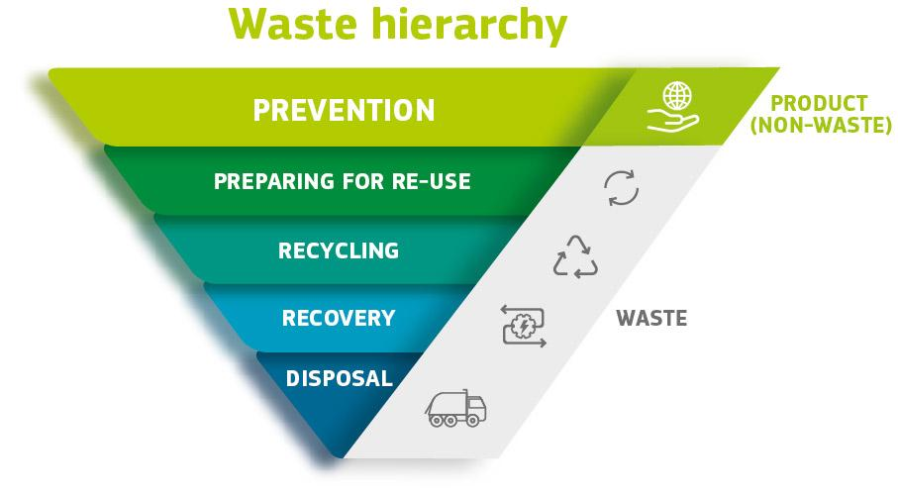
Figure 1

Figure 2 shows how Asphalt fits into this waste hierarchy and why Re-use of RAP should always be the first option to be considered. This position needs to be supported in regulations and/or procurement criteria so that sustainability and circular economy principles can be adhered to in line with EU policy objectives set out in the European Green Deal (Dec ‘19) and the Circular Economy Action Plan (March ‘20) which prioritise Prevention and Re-use over Recycling.
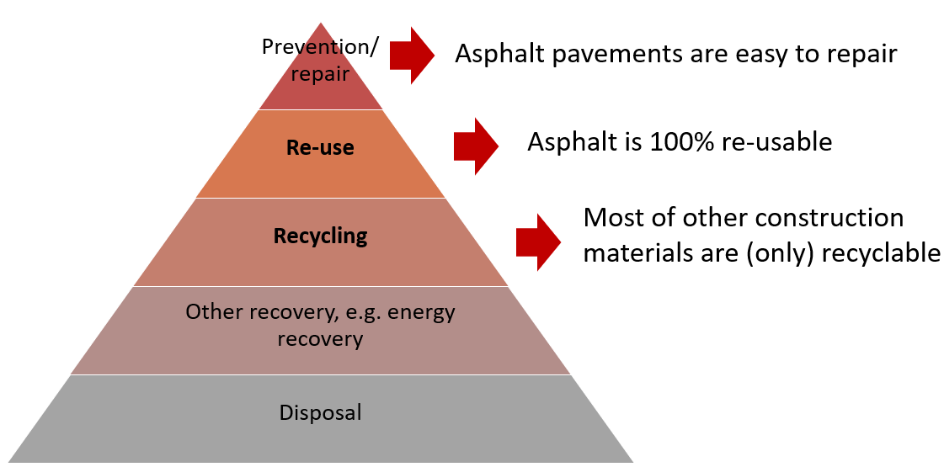
Figure 2
We are already seriously lagging our colleagues in Europe in the handling of RAP arisings. In Europe an estimated 50M tonnes of RAP is generated annually and of that, 76% is re-used into new hot or warm mixes, 20% is recycled as aggregate and approx. 4% goes to landfill (EAPA, 2020)
In Ireland we estimate that RAP arisings are currently in the region of 500,000 tonne annually. Of this, less than 50% is being returned to asphalt plants for Re-use, the greater part being recycled as aggregate (black stone) by Local Authorities and private operators.
IAPA members have to date invested in 17 plant upgrades around the country. With proper regulations in place to prioritise re-use over recycling, there is no doubt that further investment in plant modifications would follow ensuring more complete geographical coverage to handle all future RAP volumes.
The technology for re-use is already well established in these plants to ensure that all materials manufactured, using any % level of RA as constituent material, must meet the same performance requirements as materials produced using only virgin constituent materials
Where road works require the removal of asphalt layers, an assessment is completed to ensure the suitability of the materials onsite for reuse. When RAP is taken from the road surface and transported to a re-use facility it is handled as follows:
- site location of material source is recorded
- compliance with acceptance criteria for contaminants (to be removed) is checked
- material is added to RAP stockpiles,
- RAP is crushed, screened, and stored on a clean, preferably covered area
- binder content and grade of binder is ascertained
All the above is carried out in accordance with the relevant standard IS EN 13108-Part 8 2005: Reclaimed Asphalt. The reclaimed asphalt is then ready for addition to new mixes as a constituent material and the design of each new mix takes this into account.
In summary, IAPA’s position on the handling of RAP in Ireland is as follows:
- Asphalt is 100% re-usable in new asphalt mixtures. Both the bitumen and aggregate components are re-used for their original purpose in the new mix. The process can be repeated multiple times so that benefits are never lost, and circularity and sustainability are maximised.
- Recycling of RAP, as aggregate only, fails to capture the environmental and economic values embedded in the bitumen component. Recycling is at a lower level than re-use in the Waste Hierarchy.
- All RAP arisings should be re-used as it is technically feasible (up to 80% in parts of Europe) and environmentally beneficial; the bitumen component must not be ignored as happens in recycling uses.
- Asphalt Producers can capture the full value of RAP materials by investing in Re-use plant modifications (RAP enabled), but RAP availability must be guaranteed to secure the necessary investment.
- The first option must always be removal to a re-use facility before alternative uses are to be considered.
- We need a regulatory framework that supports this first option to ensure maximum carbon saving/recovery and adherence to Circular Economy principles.
- The increased sustainability of asphalt re-use over alternative uses must be supported in regulations.
IAPA members have already demonstrated their commitment, as an industry, to promoting best practice in the handling of RAP arisings, as outlined herein. As the producers of asphalt products, we have the capacity to recover and re-use these products in their entirety at the end of their service lives.

Denis Ryan, Chairman IAPA
Edmund Hegarty CEO IAPA
Email: iapa@irishconcrete.ie

